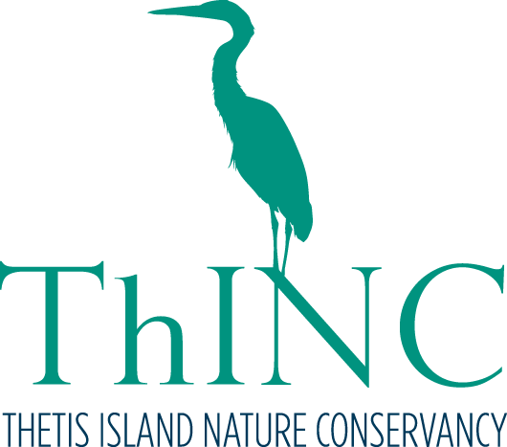Welcome to the Thetis Island Nature Conservancy Society
To become a member of the Thetis Island Nature Conservancy Society and/or a Friend of the Nature House, please print and complete this form and return it to
PO Box 13-3, Thetis Island, V0R 2Y0.

Name:_________________________________________________________________________

Mailing Address:_________________________________________________________________

City:_________________________________Province/State:______________________________

Postal Code/ZIP: _______________________Country: ___________________________________

Telephone: _________________________E-mail: _______________________________________

We offer 2 memberships, an Annual Membership which includes voting privileges at general meetings, mailing list subscription, and a discount for Friends of Nature House annual membership) and a Friends of the Nature House Membership which includes all Nature House Programs and use of Nature House equipment. A Annual Membership is not required to be a Friend of the Nature House, but please note the non-member rate.

Annual Membership
____ $5.00/year for people under 19
____ $20.00/year for adults and families

Friends of the Nature House annual membership (please circle individual or family)
____$25/$50 individual/family with ThINC membership
____$35/$70 individual/family without ThINC membership

Total donation submitted: ___________________________________

Signature: ____________________________________ Date: ______________________

How to donate:
___For a charitable tax receipt: Donate through the Cowichan Community Land Trust www.cowichanlandtrust.ca and select ‘Thetis Island Nature Conservancy’ from the drop-down menu. Please also return this form to the address below.
__No charitable tax receipt required: Return this form and a cheque made out to ‘Thetis Island Nature Conservancy’ to address below.

We’d love your help! Please check program areas you would like to participate in.

I am interested in volunteering for the following:
_____Nature House Programs _____Western Screech Owl |Nest Box Program
_____Community Bat program _____Community Food Programs
_____Shoreline monitoring/marine programs _____Nature Reserve Warden
_____Nature Reserve Trail Building/maintenance _____Restoration (e.g., invasive species control)
_____Communication (website/social media) _____Fundraising

Other skills and interests I’d like to contribute:__________________________________________________

